
COMSATS UNIVERSITY ISLAMABAD, ABBOTABAD CAMPUS
SOFTWARE ENGINEERING

ASSIGNMENT SUBMITTED BY:
AHMED NAWAZ (SP23 BSE 059)

ASSIGNMENT 1:
SDA(ANALYSIS)

SUBMITTED TO:
SIR MUKHTIAR ZAMIN

ANALYSIS:
USE CASE:
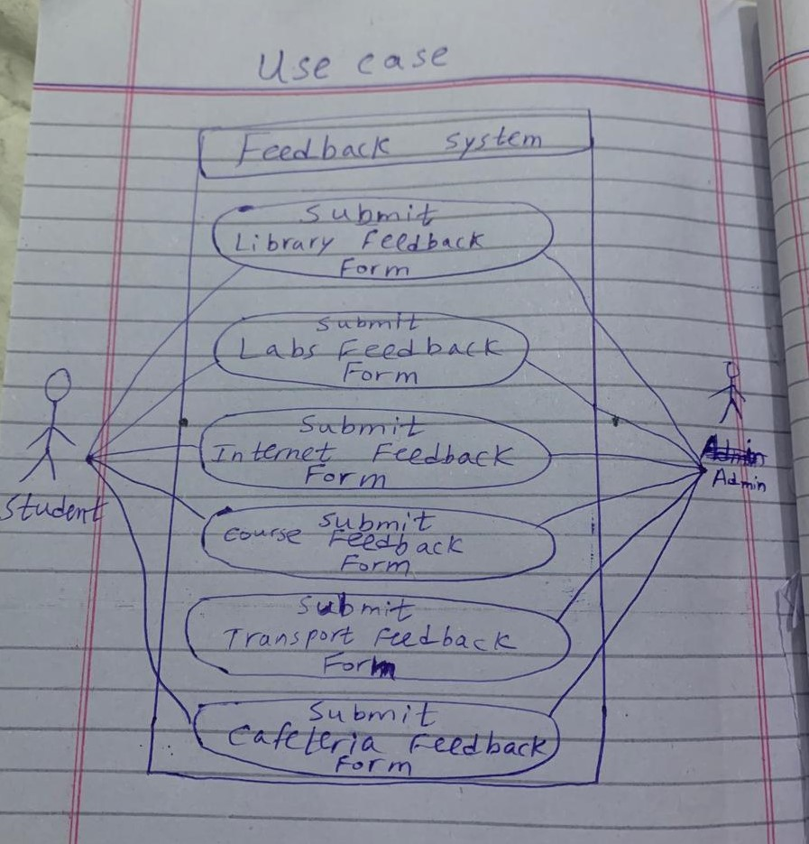

SSD:

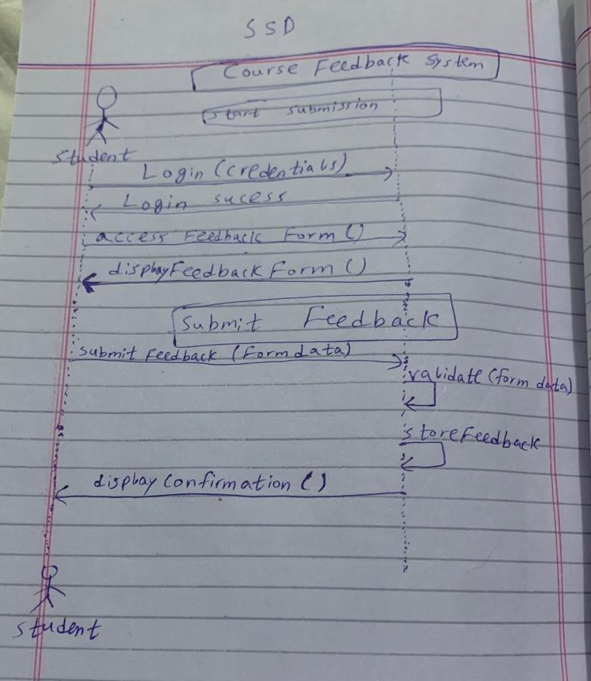

FULLY DRESSED USE CASE:
